As a security professional, we need to protect: Asset, people, property and information



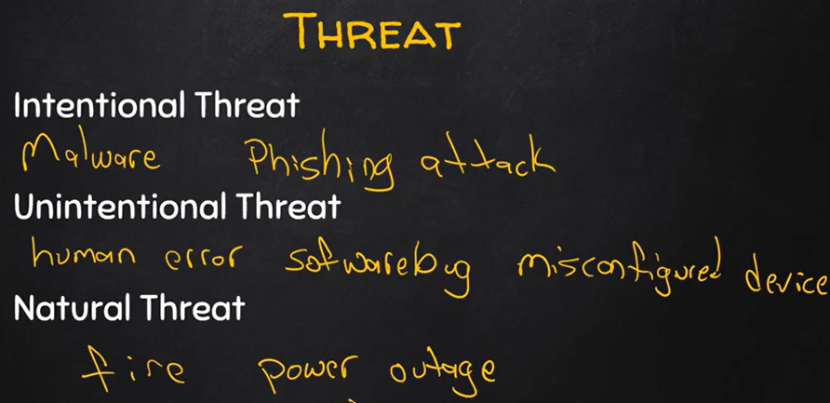

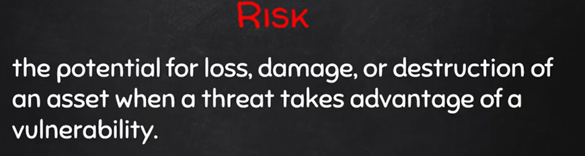

OWASP top 10

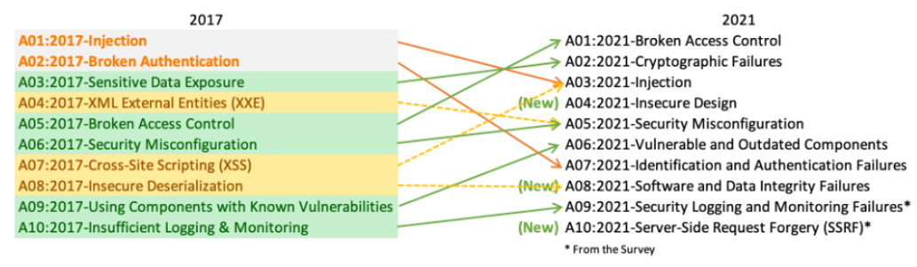

**Dynamic application security testing** (DAST) is a black box testing method that examines an application as it's running to find vulnerabilities that an attacker could exploit.( docker-bench-security) <https://github.com/docker/docker-bench-security>

**Static application security testing** (SAST) is a set of technologies designed to analyze application source code, byte code and binaries for coding and design conditions that are indicative of security vulnerabilities. (SonarQube)

SSL certificate.